Theft Alert System for Supermarkets User Manual­­

**Secure View Theft Alert System**

# Introduction

* 1. About Theft Alert System for Supermarkets Platform is a comprehensive web-based application designed for managing and monitoring CCTV cameras. It provides features for live streaming, video management, and alert systems to enhance your security operations.
  2. Key Features
     + Live video streaming from multiple cameras
     + Video management (upload, playback, edit, delete)
     + User authentication and authorization
     + Real-time alert system
     + Admin settings for system configuration

# Getting Started

* 1. System Requirements - Web browser: Latest version of Chrome, Firefox, or Safari - Internet connection: Stable connection with minimum 5Mbps download speed
  2. Accessing the Platform

1. Open your web browser
2. Navigate to the platform URL: [http://cctvsecurity.pythonanywhere.com](http://cctvsecurity.pythonanywhere.com/)
3. You will be redirected to the login page

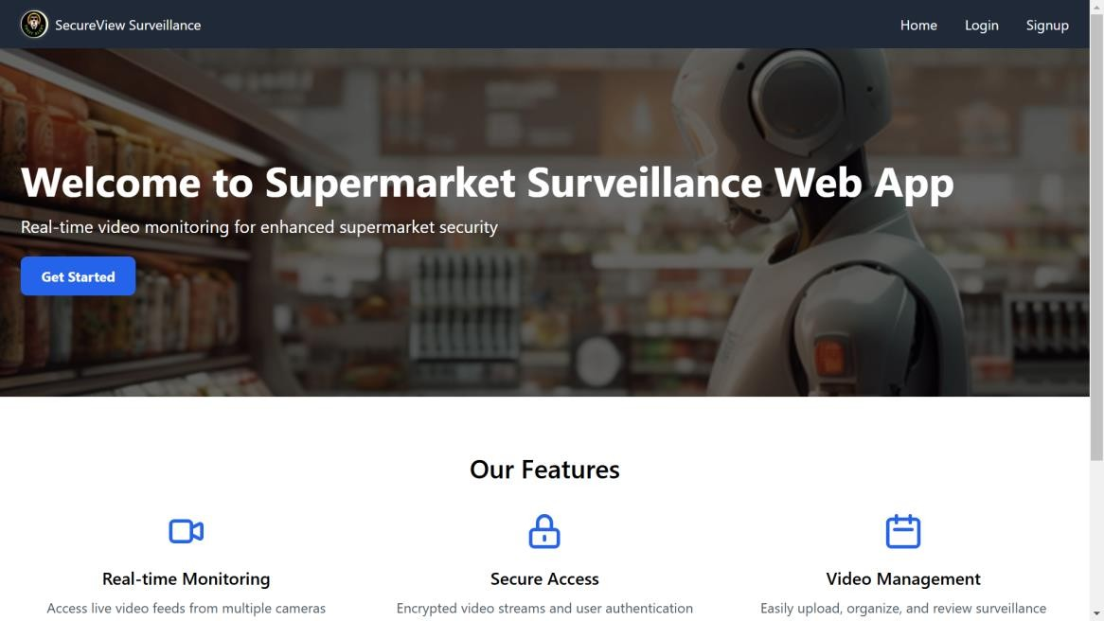

* 1. Logging In

1. Enter your username and password
2. Click the “Log In” button
3. If it’s your first time logging in, you may be prompted to change your password

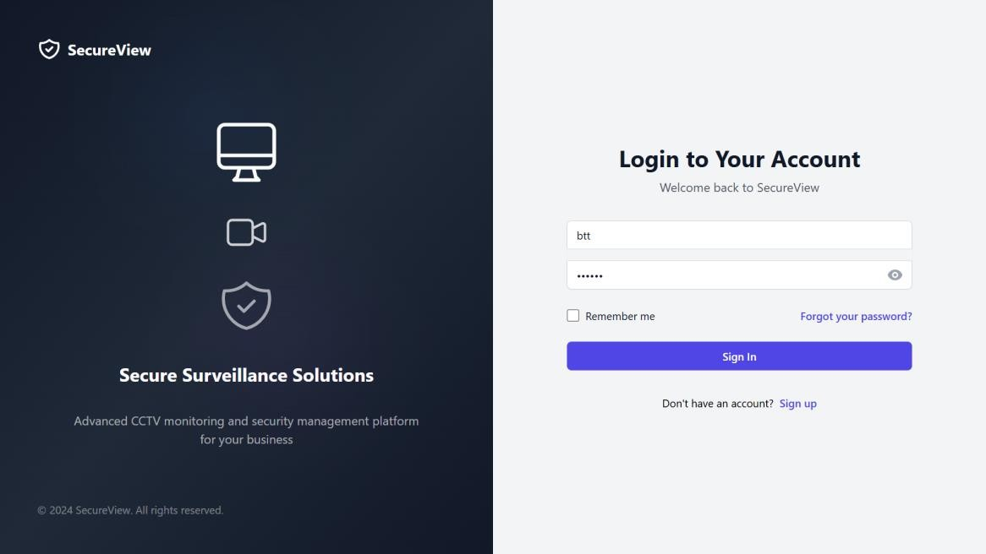

# Dashboard Overview

* 1. Understanding the Interface After logging in, you’ll see the main dashboard with the following elements:
     + Navigation menu (left sidebar)
     + Quick access buttons for common actions
     + Overview of recent alerts and system status

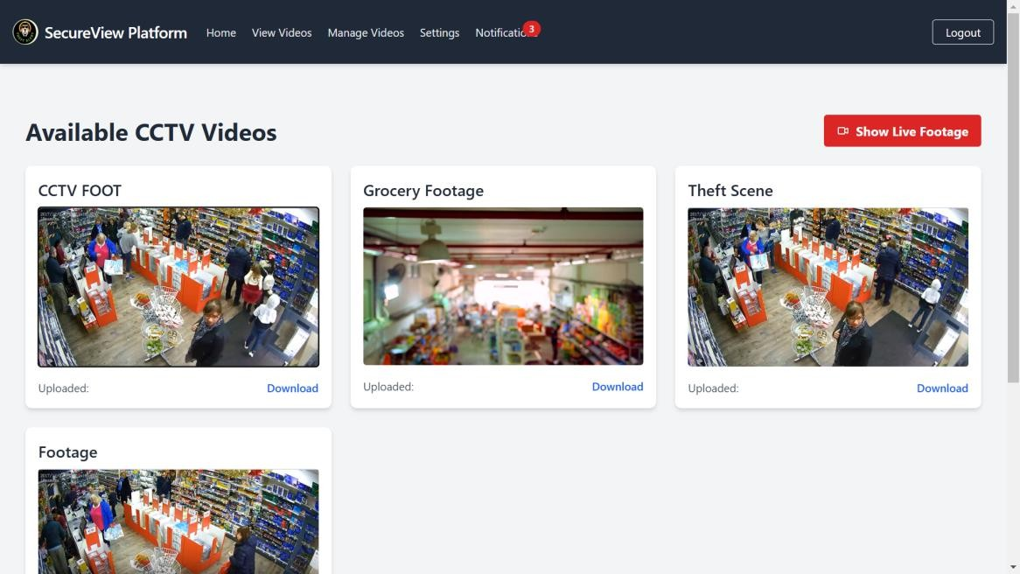

* 1. Navigation Menu The navigation menu includes the following sections:
     + Home (Dashboard)
     + Live Stream
     + Video Management
     + Alerts
     + User Profile
     + Admin Settings (for admin users only)

# Viewing Live Streams

* 1. Accessing the Live Stream Page

1. Click on “Live Stream” in the navigation menu
2. You’ll see a grid of available camera feeds

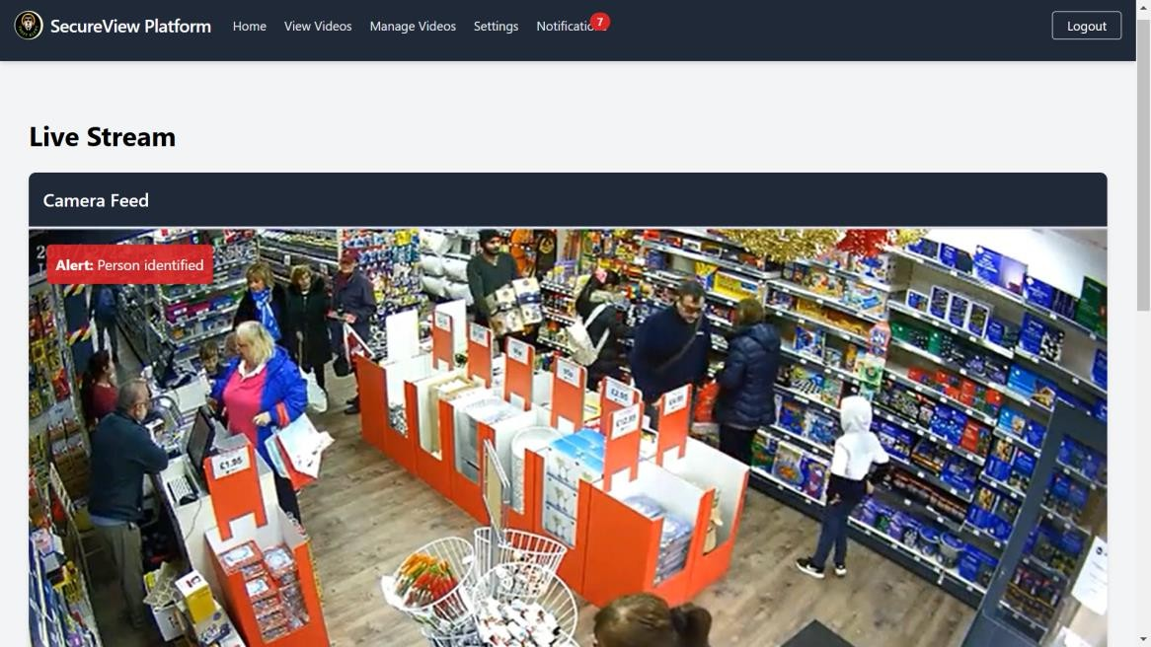

* 1. Controlling Video Playback
     + Play/Pause: Click the play/pause button on the video player
     + Full Screen: Click the full-screen button in the bottom right of the video player
     + Volume: Adjust using the volume slider (if audio is available)
  2. Understanding Stream Information Below each video feed, you’ll find:
     + Camera name and location
     + Current status (Active/Inactive)
     + Resolution and frame rate
  3. Interpreting Alerts and Events
     + Red border: Indicates an active alert for that camera
     + Event log: A scrolling list of recent events appears below the video grid

# Managing Videos

* 1. Accessing the Video Management Page

1. Click on “Video Management” in the navigation menu
2. You’ll see a list of all recorded and uploaded videos

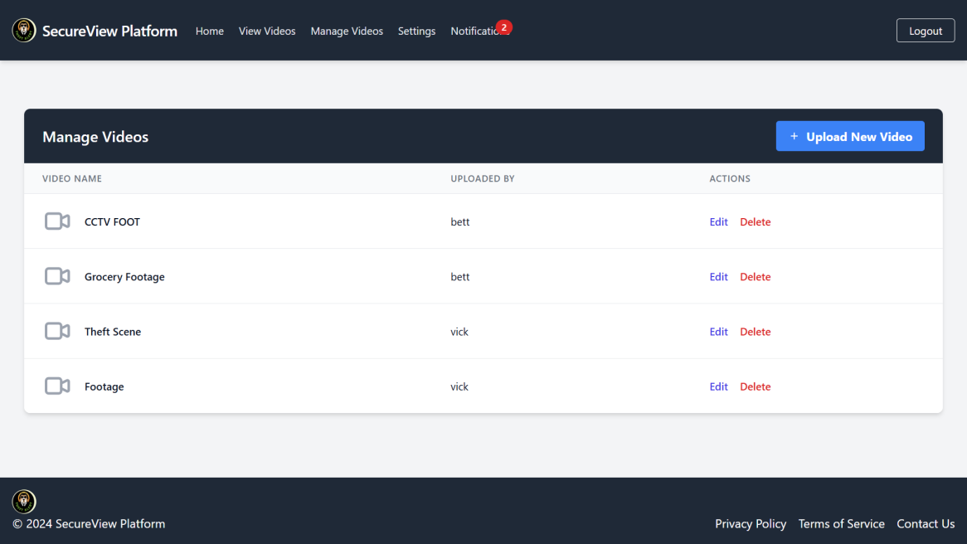

* 1. Uploading New Videos

1. Click the “Upload Video” button
2. Select the video file from your computer
3. Fill in the required metadata (title, date, camera)
4. Click “Upload” to complete the process

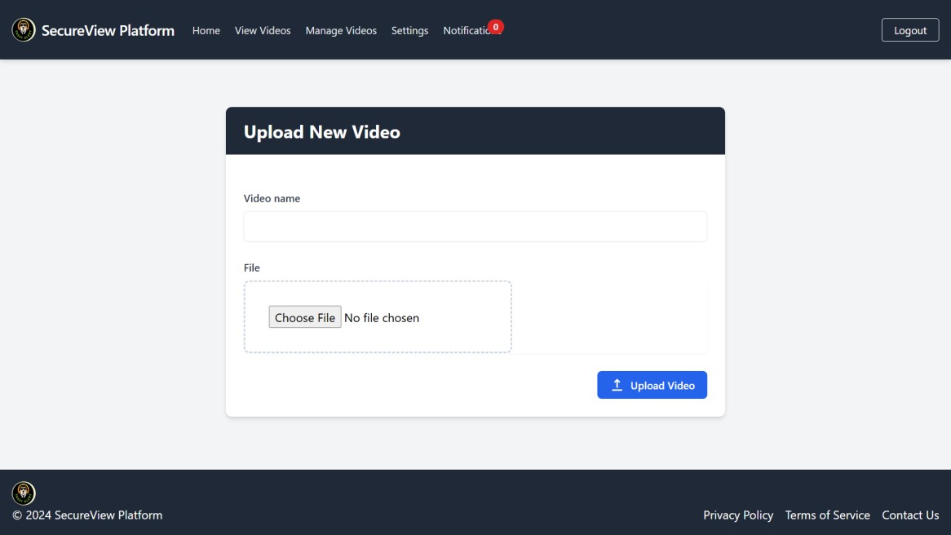

* 1. Editing Video Details

1. Find the video in the list
2. Click the “Edit” button (pencil icon)
3. Modify the video details in the form
4. Click “Save Changes”
   1. Deleting Videos
5. Find the video in the list
6. Click the “Delete” button (trash can icon)
7. Confirm the deletion in the popup dialog

# Alerts and Notifications

* 1. Understanding the Alert System The platform uses AI to detect unusual activities and generate alerts.
  2. Viewing All Alerts

1. Click on “Alerts” in the navigation menu
2. You’ll see a list of all alerts, sorted by date and priority

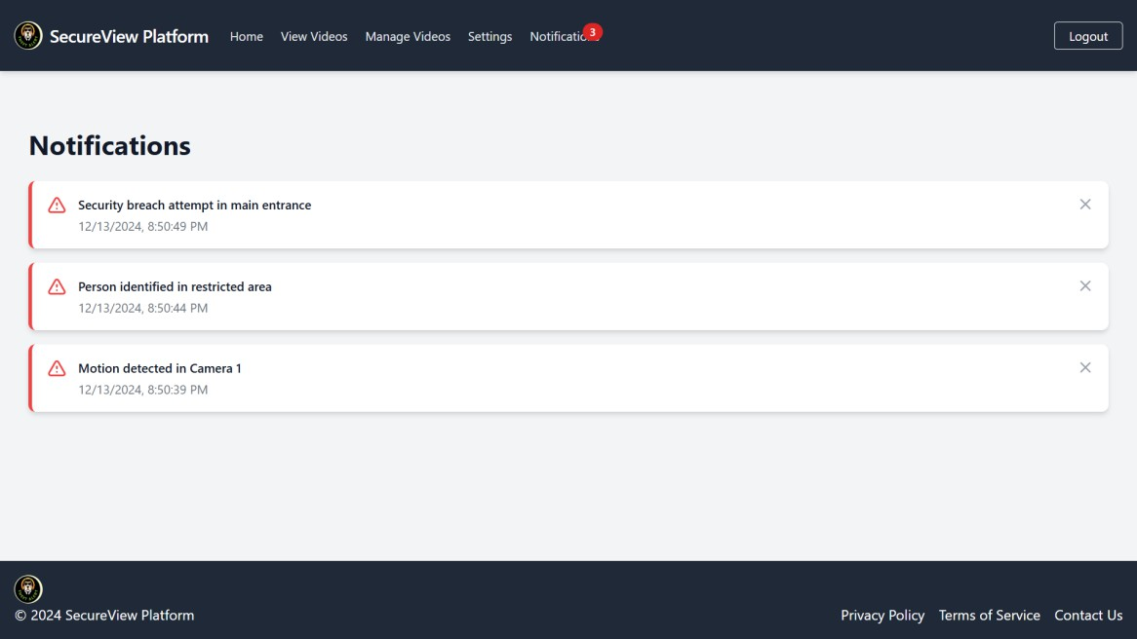

* 1. Managing Notification Settings

1. Go to your User Profile
2. Click on “Notification Settings”
3. Choose how you want to receive alerts (email, SMS, in-app)
4. Set the types of alerts you want to receive

# User Profile Management

* 1. Viewing Your Profile

1. Click on your username in the top right corner
2. Select “View Profile” from the dropdown menu

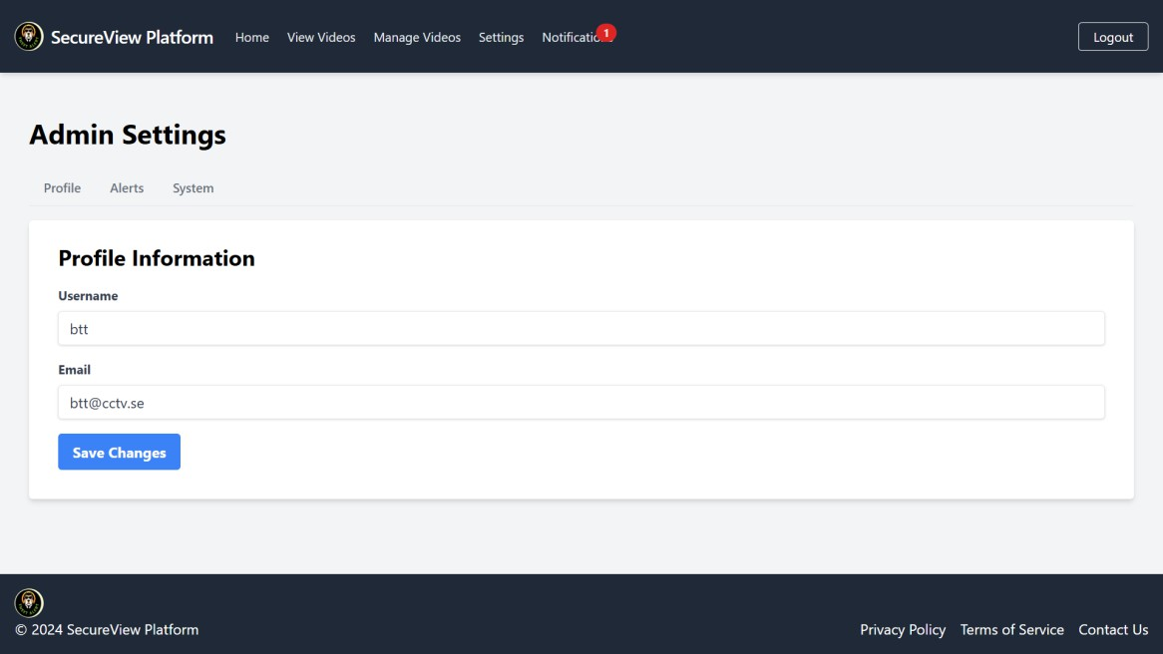

* 1. Updating Profile Information

1. On your profile page, click “Edit Profile”
2. Update your information in the form
3. Click “Save Changes”
   1. Changing Password
4. On your profile page, click “Change Password”
5. Enter your current password
6. Enter and confirm your new password
7. Click “Update Password”

# Admin Functions (for admin users only)

* 1. Accessing Admin Settings

1. Click on “Admin Settings” in the navigation menu
2. You’ll see additional options for system management
   1. Managing System Settings Here you can configure:
      * Global alert thresholds
      * Storage settings for video recordings
      * User account management

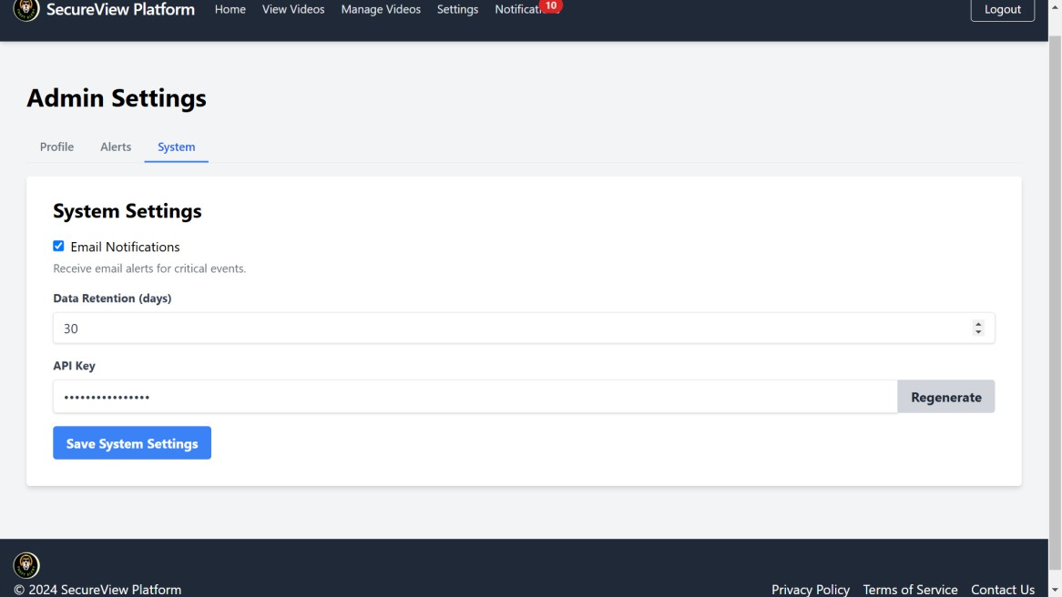

* 1. User Management

1. Click on “User Management” in the Admin Settings
2. Add new users, edit permissions, or deactivate accounts as needed

# Troubleshooting

* 1. Common User Issues
     + Can’t log in: Verify your username and password, or use the “Forgot Password” link
     + Video not loading: Check your internet connection or try refreshing the page
     + Alerts not received: Verify your notification settings in your user profile
  2. Contacting Support

If you encounter any issues not covered in this manual:

1. Click on “Help” in the navigation menu
2. Select “Contact Support”
3. Fill out the support ticket with details of your issue

# Appendix

1. Keyboard Shortcuts
   * Spacebar: Play/Pause video
   * F: Toggle full-screen mode
   * M: Mute/Unmute video
   * Left/Right Arrow: Skip backward/forward in recorded videos
2. Glossary of Terms
   * Live Stream: Real-time video feed from a camera
   * Alert: Notification of a detected unusual activity
   * Admin: User with full system management permissions
3. FAQ
4. How often are video backups made? Video backups are made daily at midnight.
5. Can I access the platform from my mobile device? Yes, the platform is fully responsive and can be accessed from any device with a web browser.
6. How long are alert logs kept? Alert logs are stored for 90 days by default. This can be adjusted in the Admin Settings.